Assignment No. 5

Title of Assignment: Consider telephone book database of N clients. Make use of a hash table implementation to quickly look up client‘s telephone number.
Relevant Theory:
A hash function is any function that can be used to map data of arbitrary size to data of fixed size. The values returned by a hash function are called hash values, hash codes, digests, or simply hashes. One use is a data structure called a hash table, widely used in computer software for rapid data lookup. Hash functions accelerate table or database lookup by detecting duplicated records in a large file.

HASHING
Hashing is a technique to convert a range of key values into a range of indexes of an array. We're going to use modulo operator to get a range of key values. Consider an example of hash table of size 20, and the following items are to be stored. Item are in the (key,value) format.

Hash_Key = DataValue % Size_of_Table

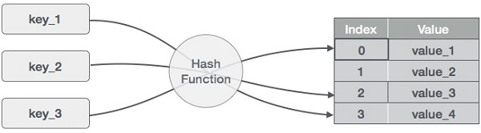

Sr. No. | Key | Hash | Array Index
1 | 1 | 1 % 20 = 1 | 1
2 | 2 | 2 % 20 = 2 | 2
3 | 4 | 4 % 20 = 4 | 4
4 | 12 | 12 % 20 = 12 | 12
5 | 14 | 14 % 20 = 14 | 14
6 | 17 | 17 % 20 = 17 | 17
8 | 13 | 13 % 20 = 13 | 13
9 | 37 | 37 % 20 = 17 | 17

HASH TABLES
Hash Table is a data structure which stores data in an associative manner. In a hash table, data is stored in an array format, where each data value has its own unique index value. Access of data becomes very fast if we know the index of the desired data.
Thus, it becomes a data structure in which insertion and search operations are very fast irrespective of the size of the data. Hash Table uses an array as a storage medium and uses hash technique to generate an index where an element is to be inserted or is to be located from.

COLLISION
Suppose we want to store Data Values 62 and 102 in hash table. Then according top hash function hash key values will be same for both the data values. Such situation is called as Collision as hash key values are same.
In order to avoid collision, hash key value should unique.

Different Techniques to avoid Collisions:
- Separate Chaining
- Open Addressing
  - Linear Probing
  - Quadratic Probing
  - Double Hashing

Linear Probing:
The simplest open addressing scheme is linear probing
• If a collision occurs when inserting data, place the record in the next empty slot
• Do a sequential search of the table, until an slot is found
• If we reach the end of the table, continue the search at the start. The table "wraps around".

Ex. We want to place records with the following keys
27, 18, 29, 28, 39, 13, 16
into a file with eleven slots using the hash function
Hash(key) = key mod 11
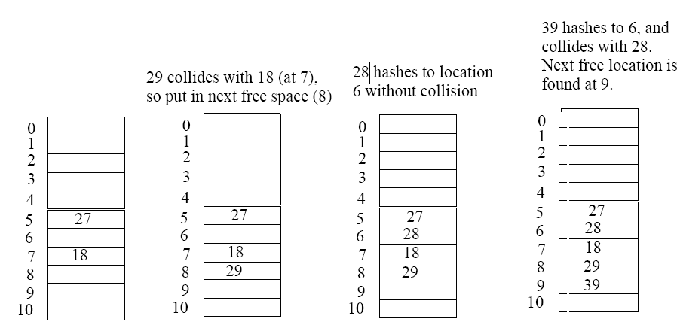

Time Complexity of Linear Probing:
Best Case: O (1)
Worst Case: O (n)

Algorithm:
1. Insert Function:
Step 1: Start
Step 2: Read the key & value pair.
Step 3: Calculate the hash index using key & table size.
Step 4: Check the hash index of hash table.
Step 5: If the location of hash index in hash table is empty, then add the data values.
Step 6. If not, delete existing record & make free space, then add the data values at position of
hash table.
Step 7. Stop

2. Search Function
Step 1: Start
Step 2: Read the data value which is to be search in the hash table.
Step 3: Calculate the hash code for the given search key
Step 4: Access the hash element.
Step 5: If the hash element is empty, the search has immediately failed.
Else check for a match between the search and data key
If there is a match, display the value along with key value and stop.
If there is no match, probe the table until match is found between the search and data key
If found the, display the value along with key value.
Else display message search element not found
Step 6: Stop
3. Delete Function
Step 1: Start
Step 2: Read the data value which is to be deleted in the hash table.
Step 3: Calculate the hash code for the given search key
Step 4: Access the hash element.
Step 5: If the hash element is empty, the delete has immediately failed.
Else check for a match between the delete key and data key
If there is a match, delete the value and stop.
If there is no match, probe the table until match is found between the delete key and data key
If found then, delete the value and stop.
Else display message delete not possible.
Step 6: Stop

4. Main Function
Step 1: Start.
Step 2: Create necessary class objects & declare necessary variables.
Step 3: Print menu as below & take choice from user:
1. Insert
2. Search
3. Delete
4. Exit
Step 4: If choice is 1, call insert function.
Step 5: If choice is 2, call search function.
Step 6: If choice is 3, call delete function.
Step 7: If choice is 4, then exit.
Step 8: Ask user whether he wants to continue or not.
Step 9: If yes then go to step 3.
Step 10: Stop.

Mathematical Modelling:
Let I be a set of Inputs {n, t_{n} } where n is no. of clients & t_{n} is an client telephone number.
Let O be a set of Outputs {R, D, S } where
R is Insert function = r(I) = H (r is insert function which stores the data values in Hash table)
D is delete hash table function = d(H) = i_{n} (d is delete hash table function on H which gives output as d_{n} an deleted value.)
S is Search Function = s(H) = a (s is search function on H which gives output as a where a € A = {Data Found, Data Not Found} )
Testing:
Test Conditions:
Give number of clients as input. Give one key for searching. Give key for deletion.
Input:
Read number of clients and their telephone numbers as input using hash table.
Output:
Perform Operation:
  - Insert
  - Search
  - Delete

FAQs:
- What is Hashing?
- What are the different techniques of hashing?
- What is Linear Probing?
- What is Complexity of Linear Probing?
Conclusion: Use of a hash table implementation is done to quickly look up client‘s telephone number.

